Mauro Pérez October 7, 2025
Exam 1: Water distribution Design
- Introduction and Context
During the 1970s Puerto Rico had a huge industrial boom with various pharmaceutical, biotech and bioengineering companies establishing themselves in the island. With these companies, the NCGS reported that there was a huge contamination in Puerto Rico’s water reserve that is seen affected to this day. IN 2017 after facing g various contamination problems then came Hurricane Maria which destroyed Puerto Rico water distribution system Puerto Rico’s. People must rely on water trucks to fill their own personal water tanks; this leads to inefficient use of water since your water reserve is limited compared to more rural areas where there is a communal water reserve.
Since the 1950s Puerto Rico shifted from small private companies to a governmental company to oversee the management of water. The PRASA (Puerto Rico Aqueduct and sewer authority. This shift marked a state led economic growth. This coincided with budgeting issues, corruption issues, and mismanagement of one of the most important governmental companies on the island.
The PRASA got exposed during the aftermath of hurricane Maria, with some people to this day still relaying on water trucks because of the old, inefficient sewage systems that PRASA installed in the 60s. Recent studies show that upwards of 55 percent of the water distributed in Puerto Rico might be lost, stolen or contaminated, with urban expansion, abandonment of artificial lakes, and overall inability to oversee the water consumption.
Many of the people that suffer from this are low-income “jíbaros” (countryside people). These communities live without functioning water tanks, they get their water by trucks that come every week to fill everyone own water tank supply. Since the water is not nearly enough, and the countrypeople might not have the intuition to conserve water end up wasting their water and could go days without showering, drinking safe water, or having any type of water.
PERSONA
Don Juan
- Lives in the mountains of Puerto Rico and is part of a small community that receives water from the PRASA every day; however, he doesn’t have the tools to properly distribute his water across the week and ends up running out
- He is around middle aged in the low-income bracket meaning his water is distributed via water trucks and not directly connected to water tank.
- Approximate Age is between 50-60 years old
- His occupation is an informal laborer, possibly living off government (ARPA act), living off food coupons and whatever he can grow, this is why water management is so important especially for agriculture people.
- With his house part of a small community that relies on water trucks to fill his water tank (cisterna) and having a relatively old pipes and water distribution system, this project might help him solve his inefficient water use.
- Thanks to the delivery system Don Juan has on way of monitoring how much Volume he wastes a day, and due to how inconsistent the water trucks can be. (https://www.tiktok.com/@andreaandlewis/video/7367877687999778090 this tiktok video is a very accurate representation and gives us context into what a rural living household can look like)

- Problems and Thought Process
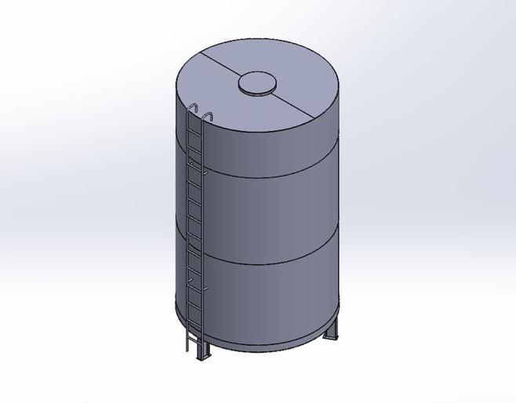
While researching for an idea to counteract this problem of inefficient water usage I first thought about using the water sensor from the 48-1 Keye studio; however, the number of liters it can detect was minuscule in for the application I wanted to use it for. So I thought like an engineer and instead of using the water level sensor, I used the ultrasonic sensor which can detect a range of around 5-450 cm, so instead of measuring the Volume directly, we use a little bit of math and physics.

We know the Volume of a cylindrical tank is:
$V=πr^{2}h$,
so, by measuring each tanks height and radius we can get the volume of the water tank.
So, let’s say that every week you get X number of liters; according to the USGS roughly 6,600 L of water are used every week by a common 3 Person Puerto Rican household. Those 6,600 L would need to be properly distributed for each day so that no water is wasted, a simple way to do this is by setting up smaller tanks with that take in x number of liters you want to use per day. Considering cleaning water, drinkable water, toilet water, shower water, etc. Basing off as well that the average person in Puerto Rico consumes roughly 371 L of water per day: “Public-supply water deliveries for domestic use accounted for 338 Mgal/d in 2015, which is 47 percent greater than in 2010, indicating an increase in domestic per capita use from 62 to 98 gallons per person per day from 2010 to 2015.” (Estimated Water Withdrawals and Use in Puerto Rico, 2015)
Using the ultrasonic sensor, we place it roughly on the limit of how much water each tank can take. As a tank fills we can set the sensor to sense the water, and only act once the water reaches a distance of 50 cm from the sensor, when that occurs, a servo motor hooked up to a pipe will turn the water flow off for that specific tanks since it is already full, we then move on to the second tank, with the same layout, then the third, then the forth, etc. Since we know the dimensions of our tank we can calculate how much each tank holds and have a proper distribution of water per day. This also allows for customization, you can divide it by day or by use, the choice is up to the person.
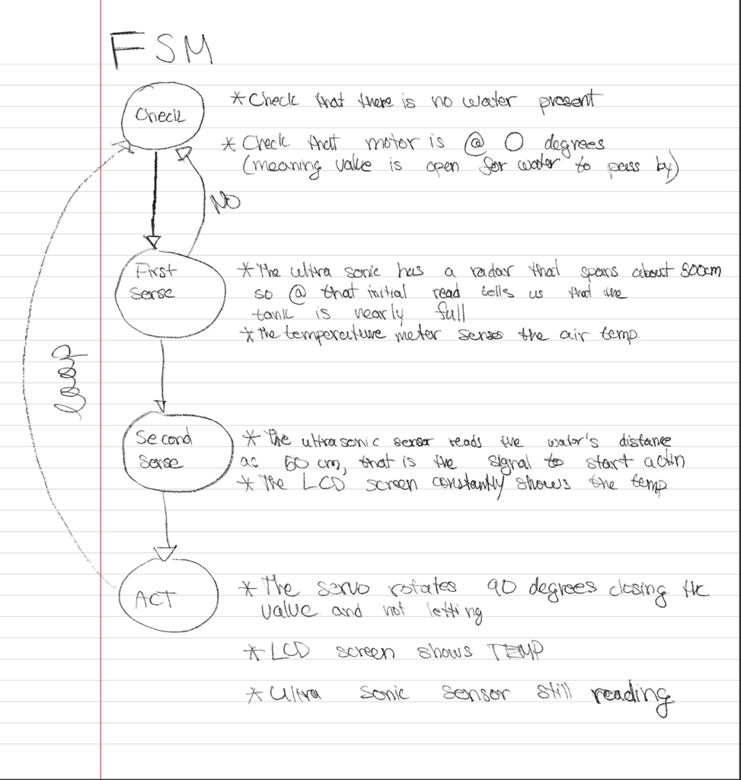
Notebook sketches:

- Parts and Resources
  - 48-1 Keye studio Ultra Sonic Sensor
    - The sensor has strong directivity and slow energy consumption. It’s a sensor largely used to measure distance with it being used as a range founder and positioning measuring instrument
    - It has 4 pins, with two being the Power supply and ground, and the other 2 are Trigger and Echo; these two pins are connected to separate Digital I/O pins.
    - The trigger pin sends a 40Hz (naked to the human ear) then measures the distance it takes for the wave to travel back to the Echo pin.
    - The longer the echo pulse the more range the sensor can detect since the transmission lasts longer. https://docs.keyestudio.com/projects/KS0349/en/latest/KS0349.html#project-46-ultrasonic-ranger
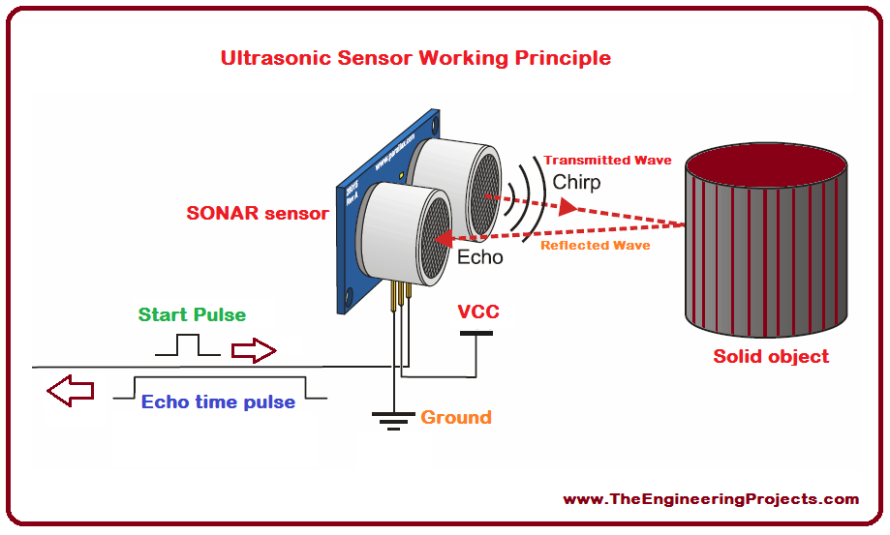
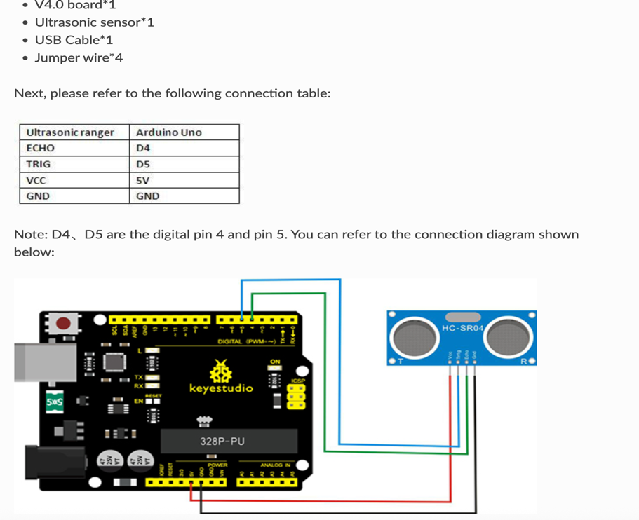

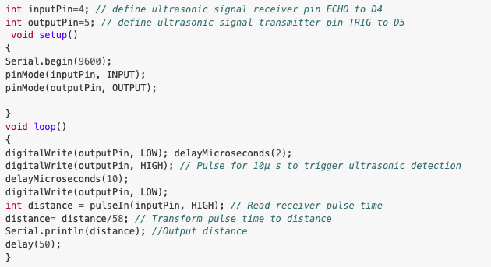
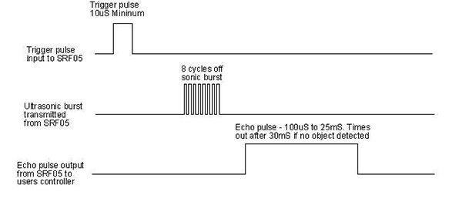

  - 48-1 Keye studio servo motor
    - The servo motor is a position rotary actuary, consisting of a gear and position sensor, essentially knowing at what degree the gear is turned and when to turn it. Include the need of a built in Servo Library so you can avoid having to hard code in the change in pulse that corresponds with the change in angle.
    - Using the Digital I/O pins by sending continuous signals, when the signal suddenly spikes in a given time frame, that is the signal for the servo motor to act and change position.
    - PWM stands for Pulse Width Modulation signal, and this is used to control the rotation angle of the servo with the standard cycle being at a fixed 20 ms (50Hz) witht the pulse width distributed at 1-2, meaning the pulse width corresponds with the angle. https://docs.keyestudio.com/projects/KS0349/en/latest/KS0349.html#project-45-micro-servo
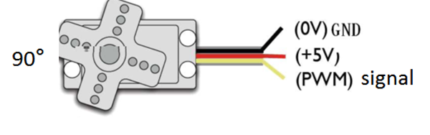
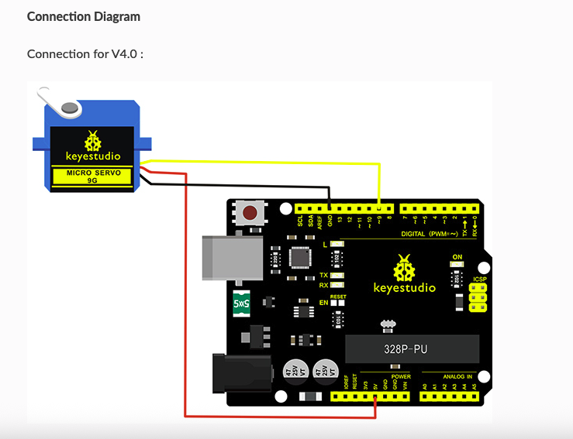

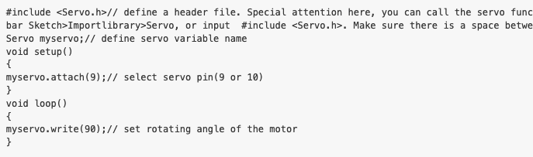
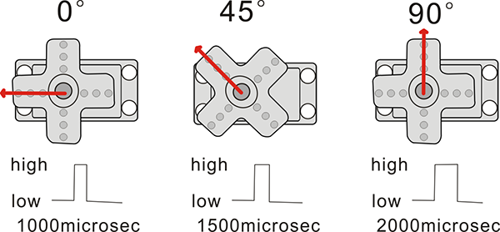

  - 48-1 Keye studio Linear Temperature sensor
    - This temperature can sense a temperature range from 0 degrees Celsius to 100 degrees Celsius, and knowing the air temperature inside the tank, this is helpful because the ultrasonic sensor operates with the speed of sound and the speed of sound varies with temperature (at 20 degrees Celsius its 343 m/s but at 0 degrees Celsius its 331 m/s), also warmer tanks accelerate bacteria growth, and knowing temperature we can adjust the sensor due to their Sensity to changes in temperature(reads at 10mV per Celsius).
    - It operates by detecting the temperature in air, It includes thermocouples, platinum resistance, thermal resistance and temperature semiconductor chips. Different to the DHT 11 that we used in one of the projects, it uses analog output meaning its receiving continuous Voltage allowing us to read the temp with the function analogRead() as we can see in the example code.
    - One of the biggest plus sides of this simple temperature reader is that it uses analog signals saving some very needed space for the Digital I/O pins. https://docs.keyestudio.com/projects/KS0349/en/latest/KS0349.html#project-19-analog-temperature
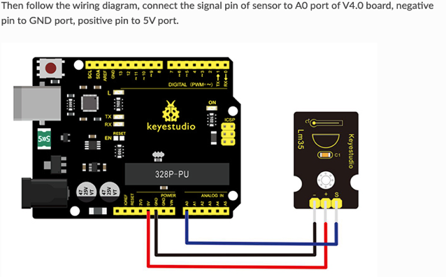
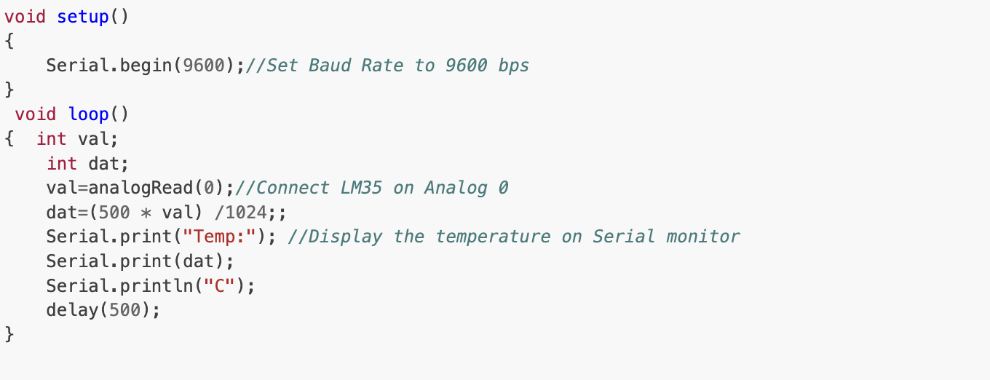

  - 48-1 Keye studio LCD Screen (4-bit connection)
    - Works like the 8-bit system utilizing the library Liquid Crystal provided in the Arduino library section.
    - Decide on the 4-bit connection to free up Digital I/O pins for the other sensors, the speed bit is even negligible for the LCD screen that we have, and uses sensors D4-D7.
    - https://docs.keyestudio.com/projects/KS0349/en/latest/KS0349.html#project-47-lcd-display
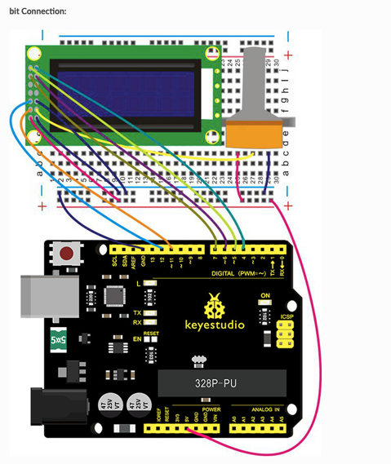

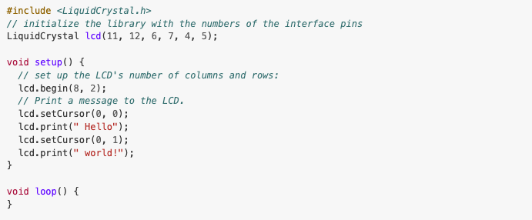

  - Jumper cables
  - Arduino R4
  - Type c cable
  - External battery for Keye studio servo motor and maintaining battery to Arduino itself
  - 600-700(roughly 200 gallons) liter Tank
  - Potentiometer

- Design and Code
Circuit Design via Tinker CAD:
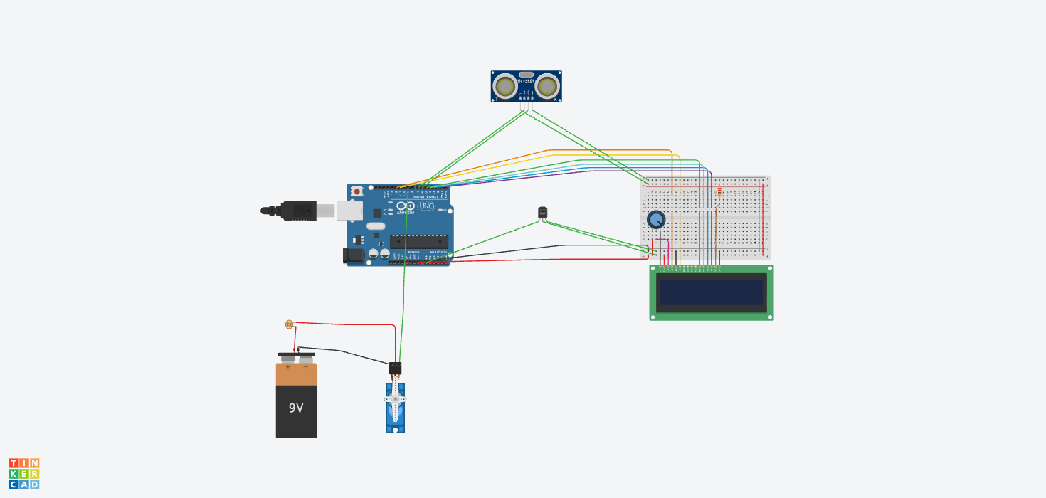

The thought process mirrors a sense, think, act model that we have been using for most of the semester.
We first check and initialize the ultrasonic sensor, the temperature sensor, the LCD and the servo motor.
We then have the first sense, as the water is rising the temperature in the air might start to change, the ultrasonic sensor won’t detect it till about 5 meters away however we might see a change in the temperature by the time the ultrasonic sensor.
The second sense is right when the tank is full and the temperature has stteled after the introduction of the water. Here we know that the tank is full since, this change is sense by the ultrasonic sensor, then an if statement (if distance < 100cm) then we move on to the final phase
After the second sense, the final phase of the FSM is to act on what it sensed, so it checked for the water height twice, then it checked for any change in the air temperature, after confirming those two all the servo needs to do is turn 90 degrees to close the valve that connects to the main water tank.
Libraries needed:
Servo.h library (uses functions like myservo.attach(I/Opin) and myservo.Write(angle at which the servo rotates)
Version: 1.2.2
Documentation: https://docs.arduino.cc/libraries/servo/

Liquid Crystal
Version 1.0.7
Documentation: https://docs.arduino.cc/libraries/liquidcrystal/

Pins:
TRIG_PIN, ECHO_PIN
SERVO_PIN
LCD_PINS or I2C_ADDR
LM35_PIN (analog)

Init LCD
Init Servo; //Check for degree to equal 0 which means the valve is open
Init ultrasonic sensor; // does not detect any distance it means that the tank is empty
If d =0 “no water is present”
Init LM35 //detect temperature present in the room without any water
First sense phase:
- d_init = readDistanceFiltered()
- tempC = readLM35_C()
- LCD shows d_init & tempC
- If echo invalid meaning that d = 0 then we keep relying the signal until it picks it up.
Second sense Phase:
- d_init = readDistanceFiltered()
- tempC = readLM35_C()
LCD shows d_init & tempC
Now in this sense phase, the temperature and distance should have changed, we can now assume that d < 100 cm, meaning it is reaching the ultra-sensor dead zone (0-2cm). If we confirm the distance is fine and the temperature is fine, then we can move on to the ACT Phase.
ACT:
This ACT phase takes care of the servo motor.
Meaning in this phase we write:
If distance from water is reasonable (d<100cm) and the temperature inside the tank is at room temperature, then we can use the function from the servo library:
myservo.write(90);// set rotating angle of the motor
by closing the valve we now have a tank full of water, this can be set up for multiple tanks.

- 4 Person Narrative
  - State of Art: Many of the applications that I have been able to find online are more DIY approaches or the other spectrum which are expensive water sensors in which the price of the instrument far exceeds the building costs, some use actual water sensor instead of ultrasonic sensors, while other use a much more powerful servo motor.
  - Who cares? The type of person that was chosen for this project was the jibaro. A person forms the countryside with little knowledge of the precarious situation the PRASA finds themselves in with water shortages all over the island. They are in desperate need of someone out there to help them with the management of water, and allocation of resources in general. This is especially true after storms or natural disasters where people don’t know the next time, they will get water for their house and need to strategically save water.
  - New Approach? With the Arduino, electrical bills aren’t severely affected by any significant power usage, they allow for customization, maybe different Arduinos for different tanks. For drinkable water I found this instructible that allows for you to build a water quality monitor, and you could combine that with this design to have a tank solely for drinking purposes.
  - Impact: This project has the potential to bring attention to something largely ignored by the mass population of the island, it raises concerns over how safe the water in Puerto Rico is for the less fortunate and offers solutions to a problem that thousands of people face every day.
Future additions: this exam ended up being long and I wanted to include a more in depth look on how to incorporate this water quality instructible into the project, however time got the best of me, however currently trying to model a working design. https://www.instructables.com/Arduino-Water-Quality-Monitoring-System/

Links:
https://brooklynrail.org/2021/08/river-rail/Colonial-Waterscapes-The-Water-Issue-in-Puerto-Rico/
https://abcnews.go.com/US/puerto-ricos-water-supply-depleted-contaminated-manufacturing-industry/story?id=98482267
https://www.instructables.com/Arduino-Water-Quality-Monitoring-System/
https://projecthub.arduino.cc/NewMC/water-level-monitor-09c018
https://lastminuteengineers.com/water-level-sensor-arduino-tutorial/
https://docs.keyestudio.com/projects/KS0349/en/latest/KS0349.html#project-46-ultrasonic-ranger
https://www.usgs.gov/search?keywords=water&f%5B0%5D=by_location%3Apuerto%20rico
https://pubs.usgs.gov/of/2021/1060/ofr20211060.pdf

